**ICP SUBMISSION-1**

**INSTALLATION OF SOFTWARES:**

Below are the screenshots indicating the installation of various softwares in my system.

**GITHUB DESKTOP:**

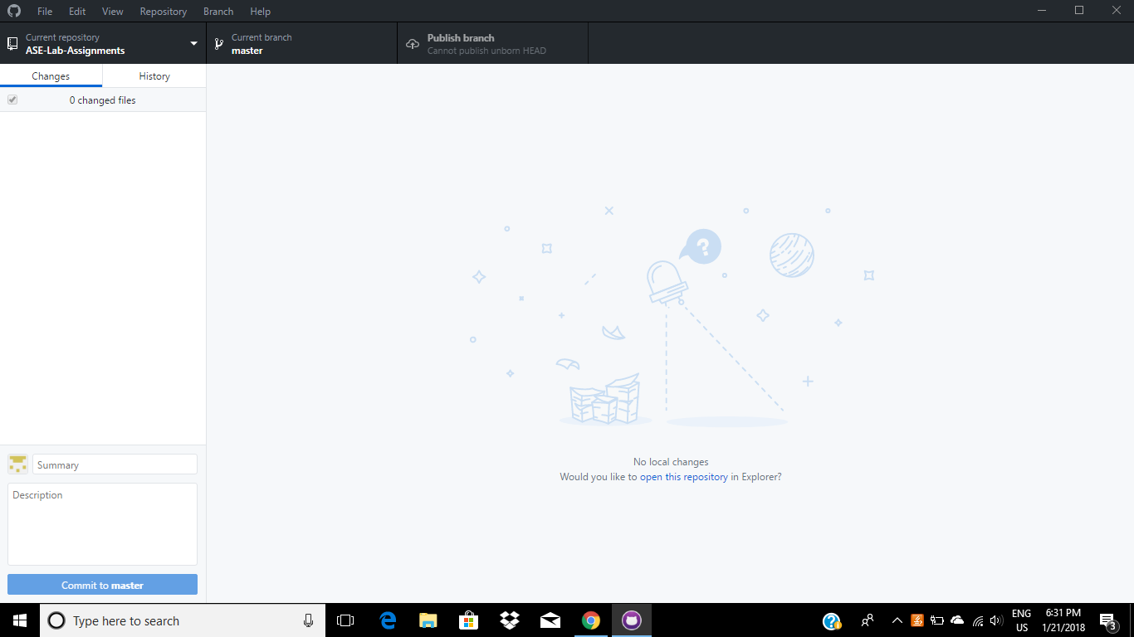

**GITSHELL:**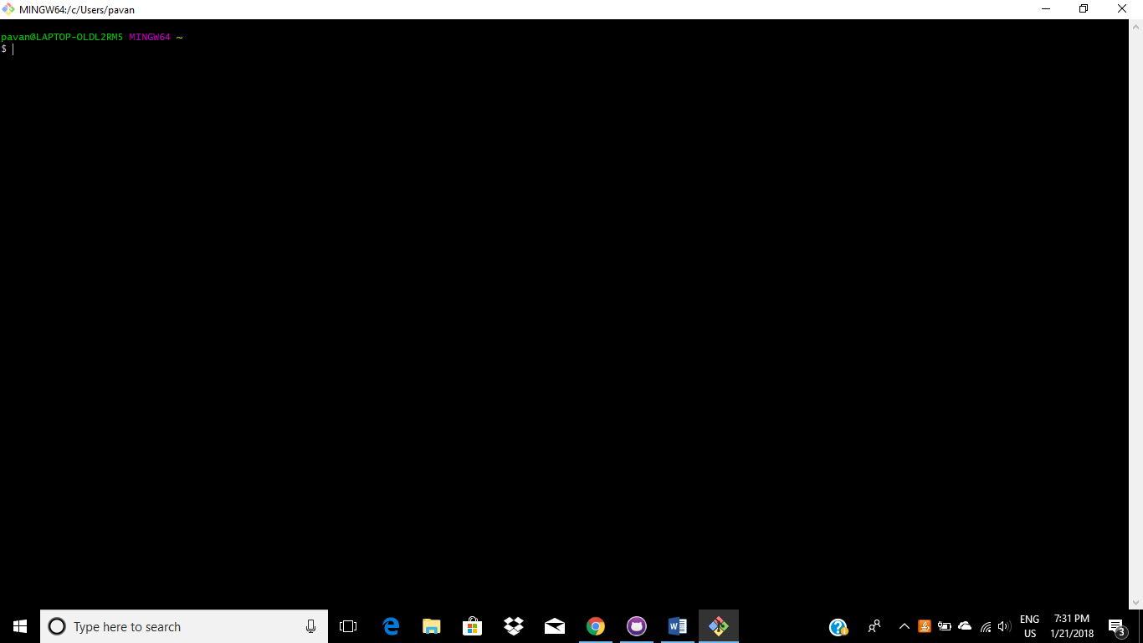

**ZENHUB:**

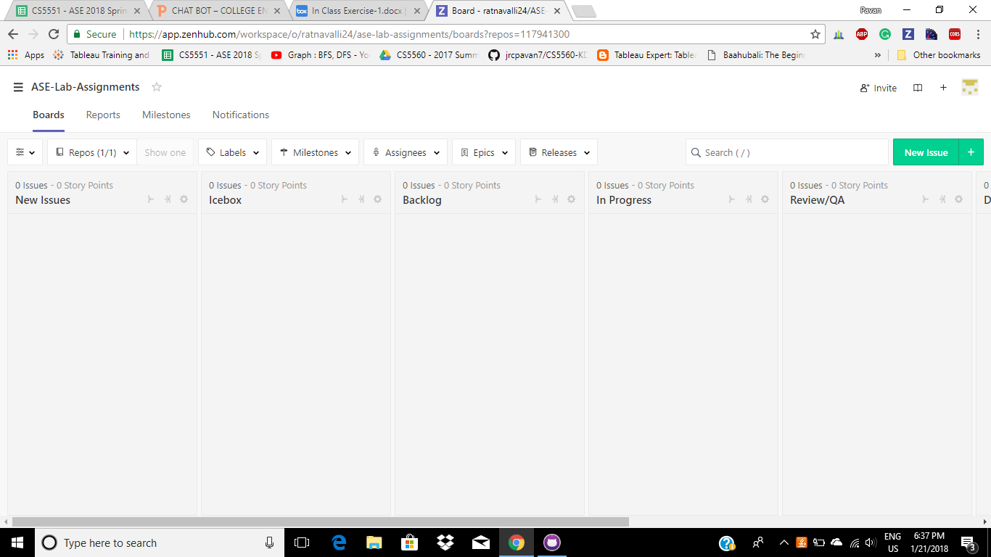

**CREATLY:**

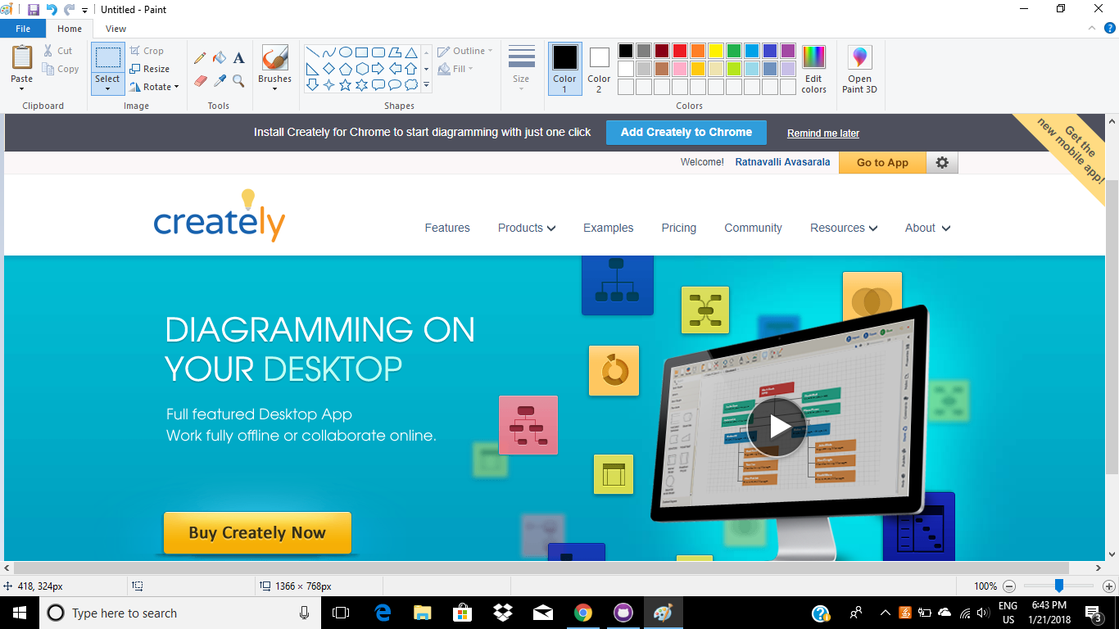

**WEBSTORM:**

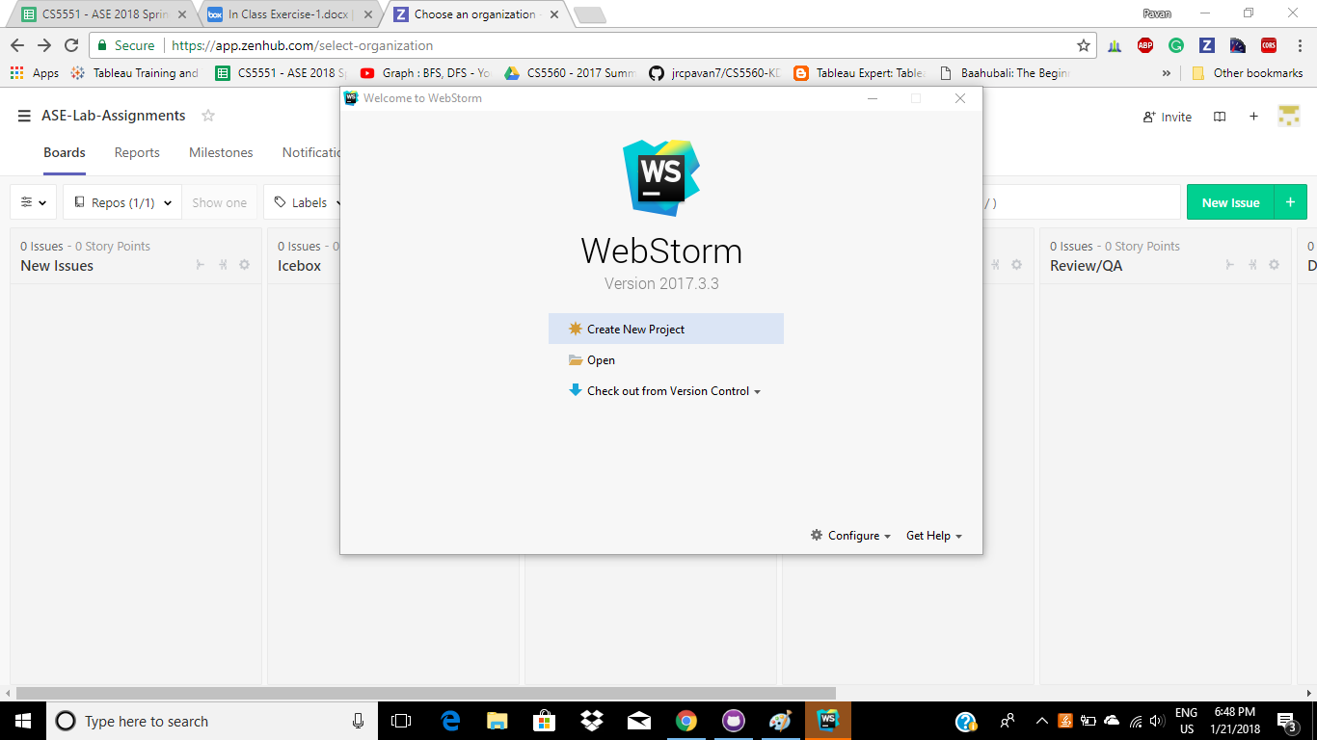

**ANDROID STUDIO:**

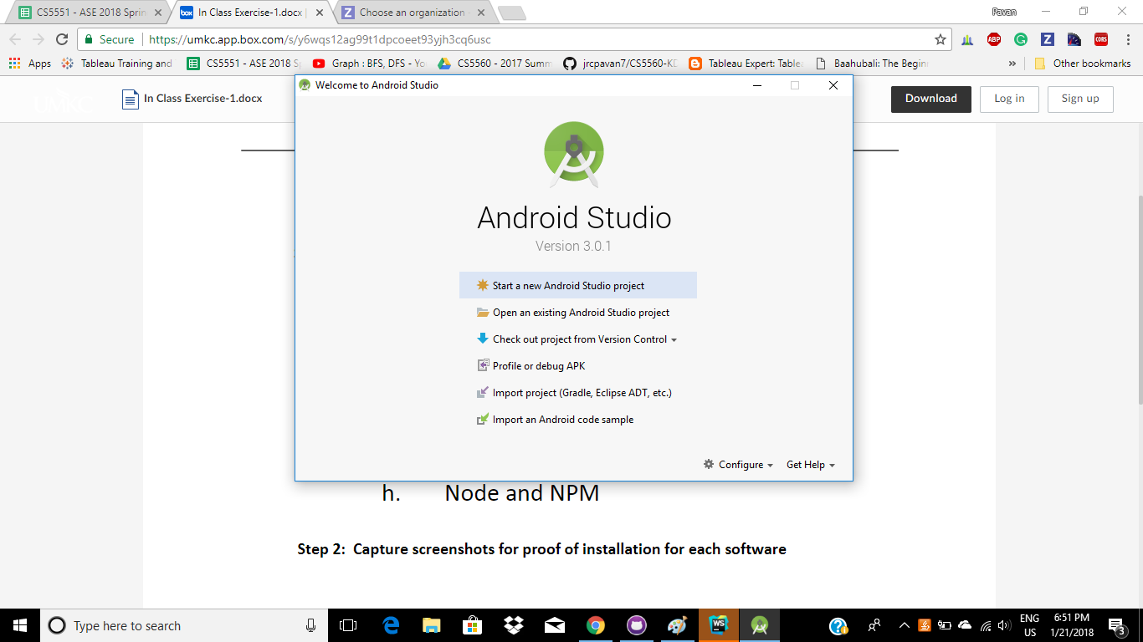

**BRACKETS:**

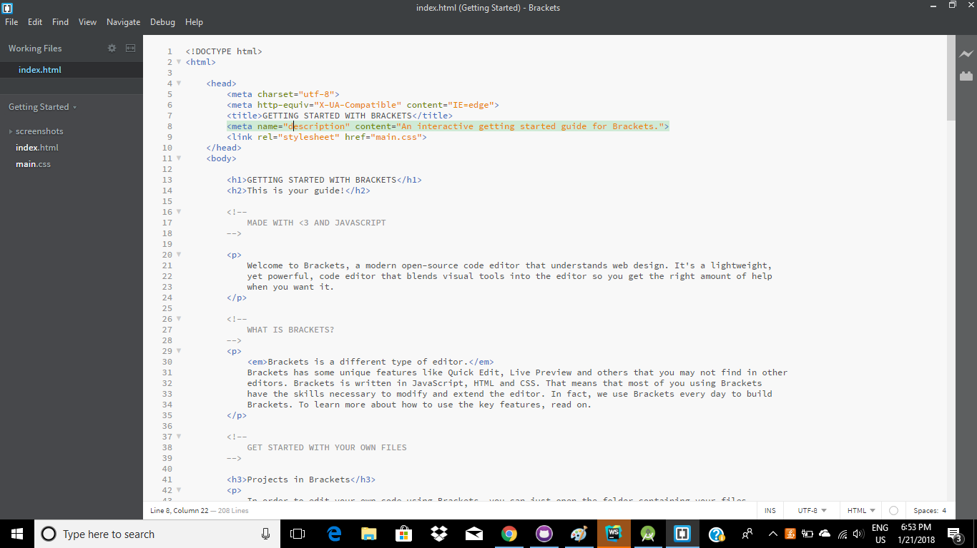

**NODE, NPM AND IONIC:**

